Pinola Moreno Agustina Sofia
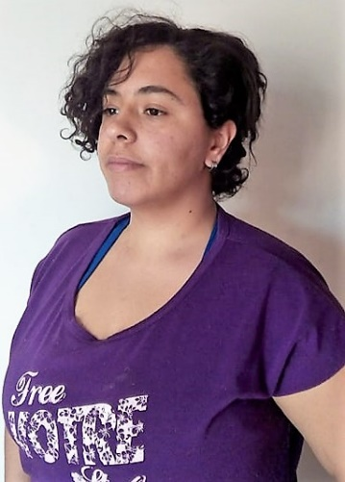
Hello there! Im Agustina and I have studied art since young and im very motivated to launch my freelancer career. I have worked for months on it in my mother country and it was time to take it to the next level. I work to give you the must satisfiying and quick work as posibe. In enjoy a good session of work with the clients and i would love to work with you. I have proyects completed in another plataforms, so i have not a lot of recomendations in freelancer.com , but please judme by yourself and contact me for some free samples! -Clear comunication, always polite -Best budget possible - Total focus in a proyect at time, to garantize quick and clean results. -English and Español My strong points: Cartoon portaits Concept art Doodles and storyboarding Fashion figurines Watercolor and acrilic traditional work Digital simple works with good resolution.

Experience
- Comic ilustrator
Oveja Negra Jun 2018 - Present
Comic Ilustrator for a news and cultural agrupation.
- Freelancer
Particular Jan 2018 - Present
Creating ilustration for particular clients in diferent on line plataforms.
- My own Fanzine
None Jan 2018 - Present
Creator, concep, lettering and sell of my own comic fanzine.
- Comic Ilustrator
Reite Apr 2017 - Present
Comic ilustrator for a magazine.

Education
- Arts
Universidad Nacional de Rosario, Argentina 2012 - 2018 (6 years)

Qualifications
- Technical in Arts and comunication (2010)
Escuela provincial de danzas Nigelia Soria
In reboard for the finish of higschool whit specialisation in arts and comunication.

Publications
- Candycat
Agustina Pinola
Fanzine dedicated to publish comics and ilustrations.

Online Portfolio
- https://www.behance.net/choconeko256f/
- https://www.freelancer.com/u/AgustinaSofia?w=f
- https://www.upwork.com/o/profiles/users/_~01d8f838cf56a1c3b8/

